**Birla Institute of Technology & Science, Pilani**

**Work Integrated Learning Programmes Division**

**First Semester 2023-2024**

**Mid-Semester Test**

**(EC-2 Regular)**

Course No. : CSI ZG518

Course Title : Database Design and Applications

Nature of Exam : Closed Book

Weightage : 30%

No. of Pages = 6

# No. of Questions = 4

Duration : 2 Hours

Date of Exam : 24/09/2023 (AN)

Note to Students:

1. Please follow all the *Instructions to Candidates* given on the cover page of the answer book.
2. All parts of a question should be answered consecutively. Each answer should start from a fresh page.
3. Assumptions made if any, should be stated clearly at the beginning of your answer.

Convert the ER to relational schemas.

**Grading:**

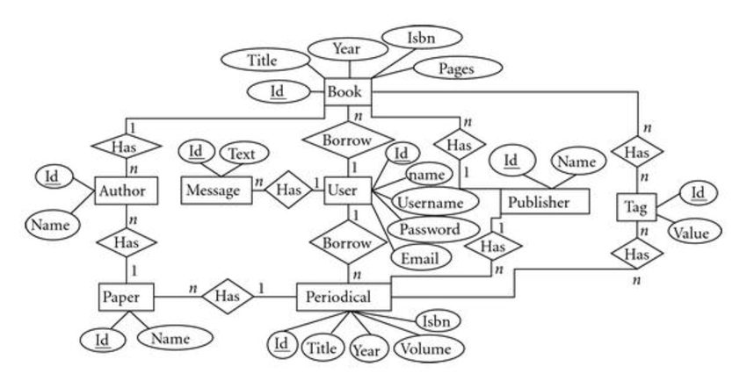

Entities, attributes and PK: **3 marks**

Relationship: 4 **marks**

Referential Integrity Constraints: **3 marks** **Total marks:10 marks**



Convert the ER to Relational Schema.

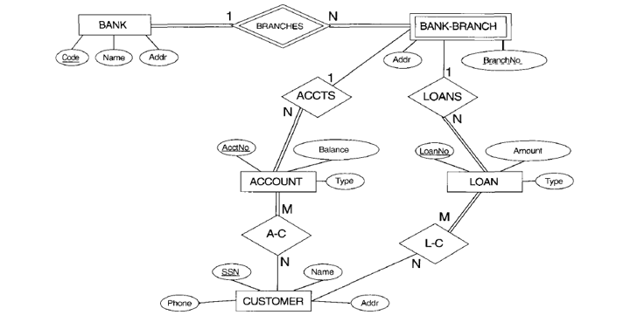

**Grading:**

Entities, attributes and PK: **3 marks**

Relationship: **4 marks**

Referential Integrity Constraints: **3 marks** **Total marks : 10 marks**



Convert the EER to Relational Schema.

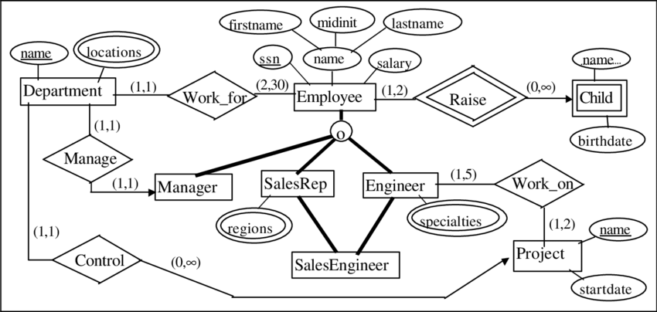

**Grading:**

Entities, attributes and PK: **3 marks**

Relationship**: 4 marks**

Referential Integrity Constraints**: 3 marks** **Total marks : 10 marks**



a.

Consider a relation schema R with attributes ABCDEFGH with functional dependencies S:

S = {B → CD; BF → H; C → AG; CEH → F; CH → B}

Which of these functional dependencies violate BCNF (Boyce-Codd Normal Form)?

**(4 marks)**

b.

Consider a relation R(A, B, C) with FD's AB → C, AC → B, BC → A.

Determine all the keys of relation R. Is the relation R in BCNF? **( 4 marks)**

**Total marks: 8 marks**



Consider a relation Movies_Screened with attributes Theatre, Movie, Day, Time, and Certificate. Sample tuples are as follows:

***Sathyam, 'Slumdog Millionaire', Wed, 18:00, 15***

***Sathyam, 'Slumdog Millionaire', Wed, 20:00, 15***

***PVR, 'Slumdog Millionaire', Wed, 20:30, 15***

***PVR, 'Vicky Christina Barcelona', Wed, 20:30, 12A***

Each movie is assigned a certificate by the Indian Board of Film Certification; the certificate value 15 means that nobody younger than 15 years of age can see this movie in a cinema. The same theatre can show a movie on multiple times during a day, and may show different movies at the same time (on different screens).

(a) Does this relation violate the second normal form requirements? Explain. **(4 marks)**

(b) Decompose this relation into BCNF, and explain why the resulting relations are in BCNF.

**(4 marks)**

**Total marks: 8 marks.**



Let F1 = {A → C, AC → D, E → AD} and F2 = {A → CD, E → AH}. Are F1 and F2 are equivalent? Total **Marks: 8 marks**



**Consider a relation REPAYMENT with the following schema;**

**REPAYMENT(BORROWER_ID, NAME, ADDRESS, LOANAMOUNT, REQUESTDATE, REPAYMENT_DATE, REPAYMENT_AMOUNT)**

Assume that this table records the repayment of loans by the borrowers. A borrower may have multiple entries if he/she has paid multiple installments.

**Write SQL and RA statements (queries) to achieve the following;**

* 1. Find all the records with information on repayments from the borrower with id equal to 42, and where the lent amount exceeds 1000. (1 mark)

1. Find the total amount repaid for every address in the repayment table. (1 mark)
2. Delete all information on the completed loans. (Note: you can find the status of the loan by summing the total repaid amount. If the total repaid amount is equal to the loan amount, then you would say that the loan is ended.) (1 mark)
3. Find all the borrower names who has unique address. (ie., you should not count the borrowers who are from the same address) (1 mark)
4. Find the total number of repayments made by every borrower. (2 mark)

**Total Marks: 6 marks**



Consider the following:

***VISITORS (Visitor Id, Name, Age, Gender, Address, Contact_no, Email, Entry_time, Exit_time, Date_of_visit, Mode_of_Transport)***

***EVENTS (Event_ID, Event_Name, Capacity, Timings, Category)***

***EMPLOYEE (Emp_ID, Emp_Name, Address, Contact_No, Gender, Department, Shift, Salary, DOB, Join_Date, Event_Id)***

***MAINTENANCE_PROBLEMS (Complaint_Id, Complaint_Name, Date_of_complaint, Status, Date_of_completion, Employee_Id, Event_Id)***

***BOOKINGS (Ticket_No, Payment_Mode, Card_type, Price_Before_discount, Price_After_Discount, No_of_visitors, Visitor_Id, Event_Id)***

**Write the SQL and Relational Algebra queries for:**

* 1. Give the name of the visitors whose mode of transport to amusement park is car? (1 mark)
  2. Give the name and address of the visitors who visited the amusement park on 2-10-2018? (1 mark)
  3. Give the Name of the events which has the accommodation for more than 200 visitors? (1 mark)
  4. What is the time of event E150? (1 mark)
  5. List the details of male employees who work during night shift?

(2 mark)

**Total marks: 6 marks**



Consider the Relational model:

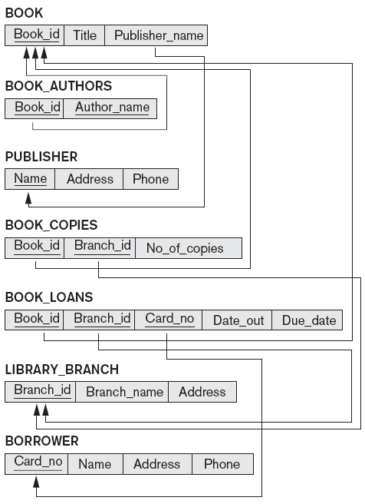

**Write SQL and RA for the following**:

1. Retrieve the names of all borrowers who do not have any books checked out .

(1 mark)

1. For each book that is loaned out from the "Sharpstown" branch and whose DueDate is today, retrieve the book title, the borrower's name, and the borrower's address.

(1 mark)

1. For each library branch, retrieve the branch name and the total number of books loaned out from that branch. (1 mark)
2. Retrieve the names, addresses, and number of books checked out for all borrowers who have more than five books checked out. (1 mark)
3. For each book authored (or co-authored) by "Stephen King", retrieve the title and the number of copies owned by the library branch whose name is "Central" (2 marks)

**Total marks: 6 marks**



A file has *r* = 30,000 Patients’ record of *fixed length.* Each record has the following fields: Name (30 bytes), SSN (9 bytes), Address (40 bytes), PHONE (10 bytes), Birth_date (8 bytes), Gender (1 byte). An additional byte is used as a deletion marker. The file is stored on the disk whose parameters are given [ie.block size *B* = 512 bytes; interblock gap size *G* = 128 bytes; number of blocks per track = 20; number of tracks per surface = 400; a disk pack consists of 15 double-sided disks, seek time is 30msec, rotational delay=12.5]

a. Calculate the record size *R* in bytes. (**1 mark**)

b. Calculate the blocking factor *bfr* and the number of file blocks *b*, assuming an unspanned

organization. (**1 mark**)

c. Calculate the average time it takes to find a record by doing a linear search on the file

(i) if the file blocks are stored contiguously, and double buffering is used (**1 mark**)

(ii) the file blocks are not stored contiguously. (**1 mark)**

d. Assume that the file is ordered by SSN; by doing a binary search, calculate the time it

takes to search for a record given its SSN value. (**2 mark**)

**Total: 6 marks**



Draw the Hash table using linear hash where h(k)=10 mod k, for the following data to be stored on disks.

|  |  |
| --- | --- |
| Record no | name |
| 45 | Jansi |
| 89 | Tania |
| 94 | Jasmine |
| 373 | Mona |

* 1. Draw the Hash table for the above data where it keeps track of record number fetched from disk for given name. (2 marks)
  2. Mars is fetched with record number 56. Redraw the Hash Table. (2 marks)
  3. Tania is deleted and so its record number as well. Redraw the Hash table. (2 marks)

**Total marks: 6 marks**



GENO corporation has branches all over India and has many departments. It uses the B+ tree for the following data:

|  |  |  |
| --- | --- | --- |
| Pname | Plocation | Departmentname |
| E45 | chennai | Distributed computing |
| H59 | Bangalore | Fluid mechanics |
| F47 | Delhi | Space |
| G20S | Pune | Aviation |

* 1. Draw the B+ tree for the above data where Pname and Plocation is used. (2 marks)
  2. F47 is completed and deployed. And the records related to this is removed from organization’s records. Redraw the B+ tree. (2 marks)
  3. K393L is the new project at Vellore and is handled by “Simulation” department. Redraw the B+ tree. (2 marks)

**Total marks: 6 marks**

===============XXXXXX===================